Looking at the Differences in Gender

and Social Class for the 2012 Election

Don Tran

University of California, Davis

Looking at the Differences in Gender

and Social Class for the 2012 Election

**Introduction**

Every day, politics continues to play out across the nation at all levels influencing our lives affecting our decisions and opinions. Back in 2012, the elections were in full swing with the Democrats championing the progress of Obama in health care, jobs, and the economy. Meanwhile, the Republican’s platform was fiscal responsibility, jobs, and protect Medicare for seniors. The political party winner will define American politics for the next four years but to do so, both major parties would need to appeal to the general public.

Each party appeals to certain demographics as it appeals to the core values of a person’s political identity. Since politics directly affects the entire United States population, everyone has a certain opinion about themselves and the political parties. For example, most people would say that the Republican Party attracts a white working class person most likely a male and is favored by the rich (Pew Research Center, 2012). This assumption is from a person’s own experiences with interactions of a party member or from the interpretation of the party’s own belief. To attract people to vote for the party is a tough task for the political parties but few have observed how the differences between males and females or social class (working class versus middle class) affect the political perception of the parties during the 2012 election.

First, there is the gender gap discussion in politics that tries to describe the voting behavior between males and females for a political candidate. It has been theorized by Howell and Day (2003) that it may be the result of a woman’s upbringing of helping others to fit the traditional biological role. This would lead them to be likely to be liberal than compared to men and lean towards the Democrats. Other researchers, however, think it is the socioeconomic status of women as they are more likely to have a high school diploma or work at low-income jobs when compared to men (Gidengil, Giles, & Thomas, 2008). In both cases, there is a divide in the gender between males and females as these identities would define a person’s political opinion. Therefore, there should be a significant difference in political opinion on themselves and the party when comparing gender.

As for the social class differences, political opinion is almost evenly distributed across for the middle class during the elections at 34% for Democrats, Independents at 35% and Republicans at 25%. On ideology, more conservatives at 34% versus liberals at 22% with 35% as moderates. Voters in both Republican and Democratic party believes that their party fights for the middle class (Pew Research Center, 2012). As for the working class, there was no relevant or comprehensive articles or reports that looked extensively at the political opinion of the working class during the 2012 election. Nevertheless, due to different social class expectations and outlooks, both working and middle class should have differences on political issues due to the geopolitical area and cost of living standards. As such, differences in political opinion exists and should be a significant difference.

**Method**

This study was conducted at UC Davis at a computer lab where participants were randomly selected from an internet ad for political research and were brought into with an appointment. In the lab, the participants answered the questions in front of the computer screen with a mouse and keyboard. Questions were formed by Inter-University Consortium for Political and Social Research. The entire questionnaire set could be done in about an hour and all participants were reimbursed for their time with a $25 gift card. The entire process took two months to complete.

Due to not applicable responses, it is important to note there were two different sample sizes for gender (*N* = 5914) and social class (*N* = 5752). This was further lowered due to more not applicable responses from the continuous variable thus each variable had different sample sizes and degrees of freedom. These differences should not alter the results significantly due to a very large sample size that correlates to a large statistical power. All tests were done with independent-sample t-test comparing gender or working class with questions that ask for the political opinion of themselves and the two major political parties (question ID A07, G01, G04, G05, G06, and G07, see Appendix A for the complete question and response options) to determine if there were any differences between males and females in gender and for social class, working class and middle class. To satisfy the hypothesis, an alpha level of .05 was chosen as it is standard in the field and applicable for these hypotheses. Question ID G06 and G07 were originally asked to rate on a scale of 1-10 but a scale of 1-5 is used to report the following statistics for simplification and should not affect the statistics.

Assumptions for this test was that participants are independent of each other as a person cannot be male and female. Social class, on the other hand, was trickier to define due to regional differences of cost of living but this study assumed a person’s opinion on their own occupation placement which is definite to them. Homogeneity of variance is assumed to be true as gender and working class is different and equal in the population and if a different sample was pooled, it may show similar results.

**Results**

In the continuous data set, all the data is skewed data (see Appendix B for histograms). This makes sense as a political opinion for a party, for example, is concentrated on a specific point of the political spectrum. As such, using the median instead of the mean is the better choice for interpreting the central tendency for the continuous variables (see Appendix C for more descriptive statistics). When looking at the sample itself, the average person reported as an independent Democrat (A07, *Mdn* = 3) who is a moderate (G01, *Mdn* = 4) in terms of ideology. In terms of political party opinion, Democrats were placed as a liberal ideology (G04, *Mdn* = 2) but placed in the middle of the road on the political spectrum placement (G06, *Mdn* = 3). The Republican party, on the other hand, were placed as conservative (G05, *Mdn* = 6) and somewhat

right of the political spectrum (G07, *Mdn* = 4).

|  |  |  |  |  |  |
| --- | --- | --- | --- | --- | --- |
|  |  |  |  |  |  |
| Table 1 |  |  |  |  |  |
| *T-test Results for Gender* |  |  |  |  |  |
| Question ID | *df* |  | *p* |  | *t* |
| A07 | 5888 |  | <.001 |  | 6.12 |
| G01 | 5767 |  | <.001 |  | 4.57 |
| G04 | 5672 |  | <.001 |  | -3.71 |
| G05 | 5651 |  | 0.017 |  | 2.36 |
| G06 | 5182 |  | <.001 |  | -7.97 |
| G07 | 5177 |  | <.001 |  | 6.45 |
| *Note.* *N* = 5914 |  |  |  |  |  |

|  |  |  |  |  |  |
| --- | --- | --- | --- | --- | --- |
|  |  |  |  |  |  |
| Table 2 |  |  |  |  |  |
| *T-test Results for Social Class* |  |  |  |  |  |
| Question ID | *df* |  | *p* |  | *t* |
| A07 | 5729 |  | <.001 | | 8.79 |
| G01 | 5630 |  | <.001 | | 3.45 |
| G04 | 5550 |  | <.001 | | -11.66 |
| G05 | 5532 |  | <.001 | | 8.65 |
| G06 | 5065 |  | <.001 | | -12.87 |
| G07 | 5059 |  | <.001 | | 12.199 |
| *Note. N* = 5752 |  |  |  |  |  |

When looking at gender and the effects of political opinion in Table 1, there is a statistical significance in all the data sets. This satisfies the hypothesis as there is a difference between males and females when it comes to political party opinion. Social class also shows the same result in Table 2. Therefore, it satisfies the hypothesis that the working class and middle class have different political party opinion.

**Discussion**

From the results above, gender and social class have a relationship with political opinion in a statistical setting. When comparing it to the Pew Research Center (2012) findings, the results were similar. These results are not shocking in any meaningful way but do confirm differences in political opinion in gender or social class standing. There is a correlation, but it is not a causation due to many difficult uncontrolled variables that happen in everyday life choices. First, there is a constant change of the political landscape causing people’s opinions to change over time thus making these results only for the 2012 elections. Events and issues like immigration, crime rates, and natural disasters can cause people to change their beliefs. People’s job occupation or wages might change in the future as workers are promoted or fired which can change their lifestyle and may change political opinions.

There is the obvious issue that a t-test might not be the best statistic test to use if the assumed homogeneity of variance was wrong. Further statistical test would need to be done in order to conclude that the homogeneity of variance is equal. Another limitation is the expectation bias that might have been present when the study was conducted which may cause some participants to change answers.

This study might have been reflective of the population of the United States during the 2012 elections and could be generalized to the population. The study also could help the claim of the gender gap in politics as these results back up the notion of differences in gender opinion. There are few studies that investigate the differences of social class on political opinion in the United States as most of the studies focus on the middle class, are from countries abroad or are outdated. As such, it was challenging to find relevant articles that solely looked at the working class on political opinion. More research is needed on this group as the working class makes up a huge portion of the United States population.

References

Gidengil, E., Giles, J., & Thomas, M. (2008). The Gender Gap in Self-Perceived Understanding of Politics in Canada and the United States. Politics & Gender, 4(4), 535-561.

Howell, S. E. and Day, C. L. (2000), Complexities of the Gender Gap. *Journal of Politics, 62*, 858-874.

Pew Research Center. (2012, August 23). The Lost Decade of the Middle Class. Retrieved November 14, 2018, from http://www.pewsocialtrends.org/2012/08/22/the-lost-decade- of-the-middle-class/

Appendix A

**Categorical**

**R01 Gender**

Gender of respondent

(1) Male, (2) Females

**R18: Social class**

Most people say they belong to either the middle class or the working class. Do you ever think of yourself as belonging in one of these classes? Which one?

1. Middle Class, (2) Working Class

**Continuous**

**A07: Party identification**

Generally speaking, do you consider yourself a Democrat, a Republican, an Independent, or what? If Democrat or Republican, would you call yourself a strong Democrat/Republican or a not very strong Democrat/Republican? If independent, do you think of yourself as closer to the Republican Party or to the Democratic Party?

(1) Strong Democrat (2) Weak Democrat (3) Independent Democrat (4) Independent (5) Independent Republican (6) Weak Republican (7) Strong Republican

**G01 Ideology**

Where would you place yourself on this seven point liberal/conservative scale?

(1) Very liberal (2) Liberal (3) Slightly liberal (4) Moderate (5) Slightly conservative (6) Conservative (7) Very conservative

**G04 Democratic Party: Ideological placement**

Where would you place the Democratic Party on this seven point liberal/conservative scale?

(1) Very liberal (2) Liberal (3) Slightly liberal (4) Moderate (5) Slightly conservative (6) Conservative (7) Very conservative

**G05 Republican Party: Ideological placement**

Where would you place the Republican Party on this seven point liberal/conservative scale?

(1) Very liberal (2) Liberal (3) Slightly liberal (4) Moderate (5) Slightly conservative (6) Conservative (7) Very conservative

**G06 Dem Party: Left-right placement**

Where would you place the Democratic Party on a scale of 0 to 10 where 0 means the left and 10 means the right? (Responses have been collapsed into five categories.)

(1) Left (2) Somewhat left (3) Middle of the road (4) Somewhat right (5) Right

**G07 Rep Party: Left-right placement**

Where would you place the Republican Party on a scale of 0 to 10 where 0 means the left and 10 means the right? (Responses have been collapsed into five categories.)

(1) Left (2) Somewhat left (3) Middle of the road (4) Somewhat right (5) Right

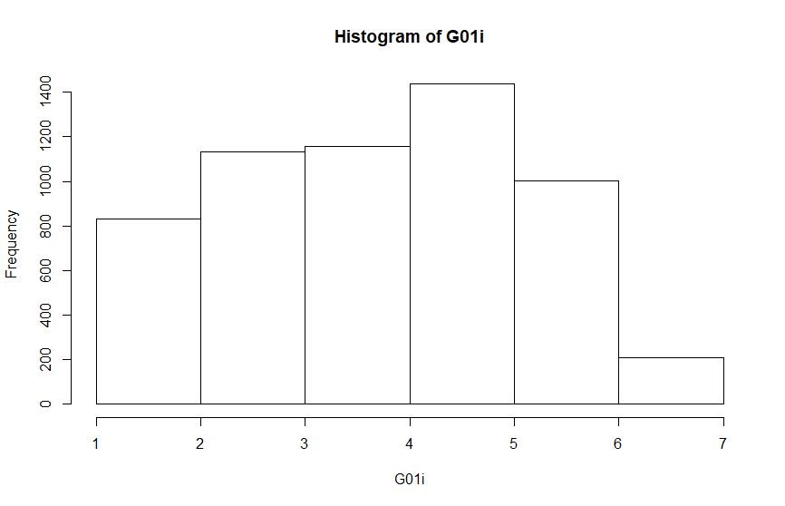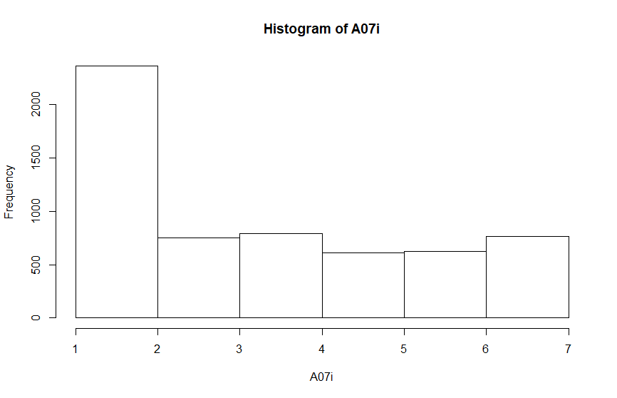Appendix B

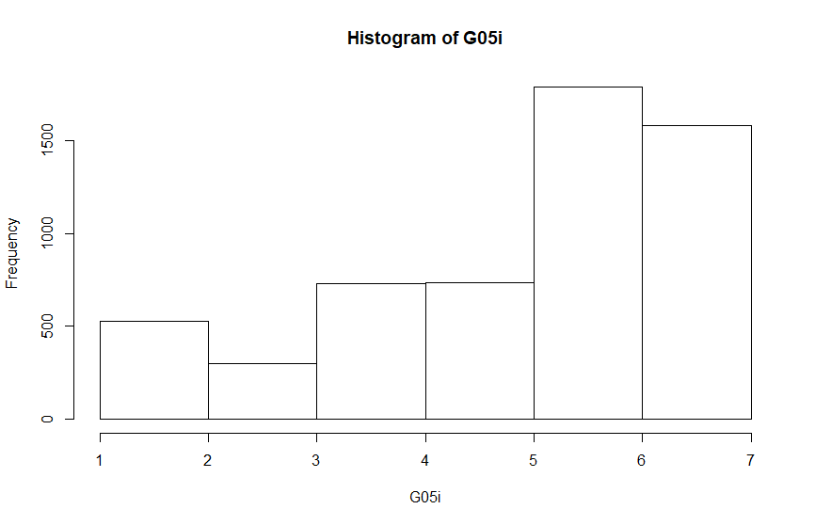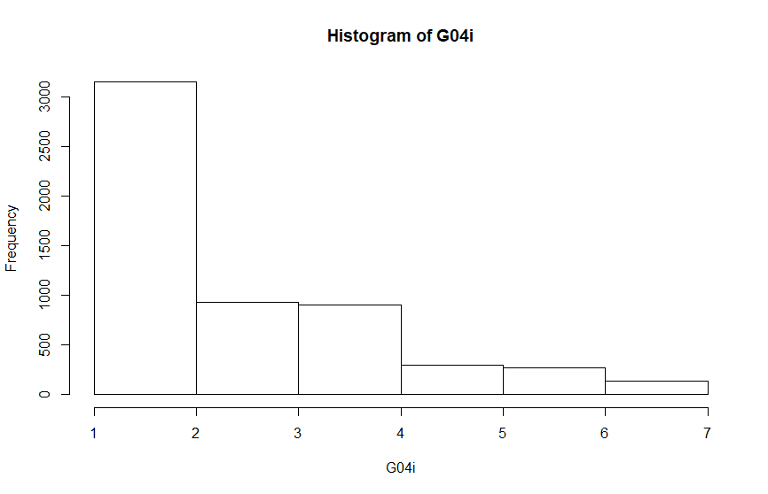

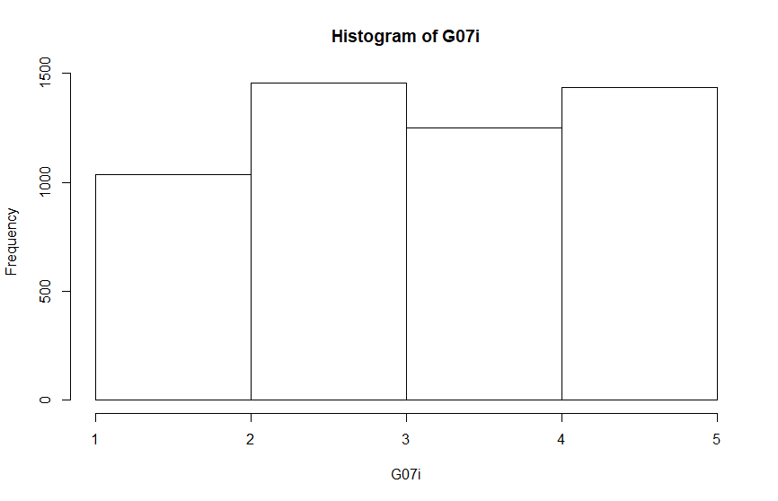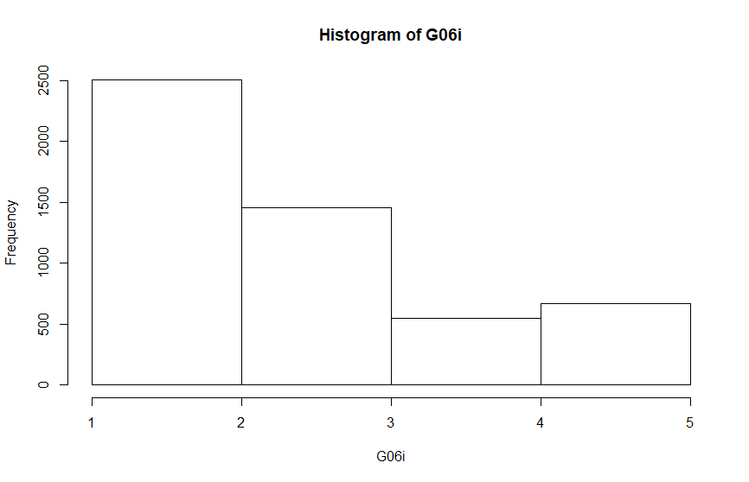

Appendix C

**Categorical Variable**

R01 (Gender): (1) Male, (2) Females

R18 (Social Class): (1) Middle Class, (2) Working Class

**Continuous Variable**

A07 (Party identification): (1) Strong Democrat (2) Weak Democrat (3) Independent Democrat (4) Independent (5) Independent Republican (6) Weak Republican (7) Strong Republican

G01 (Ideology): (1) Very liberal (2) Liberal (3) Slightly liberal (4) Moderate (5) Slightly conservative (6) Conservative (7) Very conservative

G04 (Democratic Party: Ideological placement): (1) Very liberal (2) Liberal (3) Slightly liberal (4) Moderate (5) Slightly conservative (6) Conservative (7) Very conservative

G05 (Republican Party: Ideological placement): (1) Very liberal (2) Liberal (3) Slightly liberal (4) Moderate (5) Slightly conservative (6) Conservative (7) Very conservative

G06 (Dem Party: Left-right placement): (1) Left (2) Somewhat left (3) Middle of the road (4) Somewhat right (5) Right

G07 (Rep Party: Left-right placement): (1) Left (2) Somewhat left (3) Middle of the road (4) Somewhat right (5) Right

|  |  |  |  |  |  |  |  |
| --- | --- | --- | --- | --- | --- | --- | --- |
| Table C1 |  |  |  |  |  |  |  |
| *Descriptive Statistics for Continuous Variable* |  |  |  |  |  |  |  |
| Questions ID | *N* |  | *M* |  | *Mdn* | | *SD* |
| A07 | 5890 |  | 3.524 |  | 3 |  | 2.11 |
| G01 | 5769 |  | 4.185 |  | 4 |  | 1.48 |
| G04 | 5674 |  | 2.731 |  | 2 |  | 1.52 |
| G05 | 5653 |  | 5.315 |  | 6 |  | 1.68 |
| G06 | 5184 |  | 2.651 |  | 3 |  | 1.3 |
| G07 | 5179 |  | 3.489 |  | 4 |  | 1.28 |
| *Note.* All N/A answers were removed |  |  |  |  |  |  |  |

*M*:

A07: 3.5243

G01: 4.1850

G04: 2.7312

G05: 5.3154

G06: 2.6510

G07: 3.4893

*Mdn:*

A07: (3) Independent Democrat

G01: (4) Moderate

G04: (2) Liberal

G05: (6) Conservative

G06: (3) Middle of the road

G07: (4) Somewhat Right

Mode:

R01: (2) Females 3069

R08: (1) Middle Class 3041

A07: (1) Strong Democrat 1485

G01: (5) Slightly conservative 1436

G04: (2) Liberal 1921

G05: (6) Conservative 1784

G06: (3) Middle of the road 1457

G07: (3) Middle of the road 1455

Variance:

A07: 4.4529

G01: 2.1768

G04: 2.3027

G05: 2.8115

G06:1.6820

G07: 1.6315

*SD*:

A07: 2.1102

G01: 1.4754

G04: 1.5175

G05: 1.6768

G06: 1.2969

G07: 1.2773